Decision Support System (DSS): Phase 1 Report
1. Program's Realization of the System
The developed Decision Support System (DSS) is realized as a modern, full-stack web application designed to store, manage, and structure data required for complex decision-making. The system strictly adheres to a Client-Server architecture, ensuring a clear separation of concerns between the user interface and data processing.
Technology Stack:
- Backend: Developed using Node.js with the Express framework. The application utilizes modern ECMAScript Modules (ESM) for cleaner module management.
- Frontend: Built with React and bundled via Vite for optimized performance. The user interface is styled using Tailwind CSS, providing a responsive and accessible user experience. HTTP communication with the server is handled by the Axios library.
- Database: A relational MySQL database is used to ensure data integrity and enforce strict relational mapping between entities.
- Containerization: The database environment is containerized using Docker and orchestrated via docker-compose, allowing for isolated, reproducible, and rapid deployments.
- Validation: Strict runtime data validation is enforced on all incoming API requests using Ajv (Another JSON Schema Validator), preventing malformed data from reaching the core business logic.
Current Capabilities: In this initial phase, the system provides full CRUD (Create, Read, Update, Delete) capabilities. Users can manage independent workspaces (Projects), define custom choices (Alternatives), establish evaluation parameters with specific optimization directions and weights (Criteria), and populate the intersection data (Evaluation Matrix).
2. Overview of Architecture
The system is engineered using a strict Layered Architecture (n-tier architecture) on the backend. This design pattern was deliberately chosen to maximize maintainability, facilitate unit testing, and provide a highly decoupled environment necessary for the future integration of the mathematical DSS Analytics module.
The backend application is divided into the following distinct functional layers:
2.1. Routing and Middleware Layer (/routes, /middlewares)
This acts as the entry point for all HTTP requests.
- Routes: Map specific URL endpoints (e.g., GET /api/alternatives) to their corresponding controller functions.
- Middleware: Intercepts requests before they reach the controller. The primary middleware implemented is the validation interceptor, which compiles Ajv schemas (/schemas) to verify request bodies. If validation fails, it immediately returns a 400 Bad Request, adhering to the "Fail-Fast" principle.
2.2. Controller Layer (/controllers)
Controllers are strictly responsible for handling HTTP protocols. They extract parameters, query strings, and payloads from the incoming request, pass this data to the Service layer, and format the final HTTP response (e.g., returning 201 Created or 404 Not Found). Controllers contain zero business logic and execute no database queries.
2.3. Service Layer (/services)
This is the core of the application where all business logic resides.
- Currently, the service layer orchestrates data validation and coordinates with the repository layer to fulfill CRUD operations.
- Extension Point: This layer is intentionally designed to house the future AnalyticsService. Because the service layer is decoupled from HTTP requests and SQL queries, the mathematical convolution algorithms (like WSM or SAW) can process the matrix data natively in JavaScript without architectural friction.
2.4. Data Access Layer / Repository (/repositories)
The repository layer handles all direct interactions with the MySQL database. It uses the mysql2/promise library to execute raw, parameterized SQL queries. By isolating SQL syntax within repositories, the rest of the application remains database-agnostic.
2.5. Frontend Architecture
The React client mirrors this structured approach. It utilizes React Router for declarative navigation between the Project Dashboard and the detailed Workspace. API calls are abstracted into a dedicated client module (src/api/client.js), ensuring that components remain focused on state management and UI rendering rather than network protocols.
3. Scheme of Database (ER-Diagram)
The relational schema is designed in the Third Normal Form (3NF) to eliminate data redundancy. It consists of four primary tables, utilizing cascading deletes to maintain referential integrity.
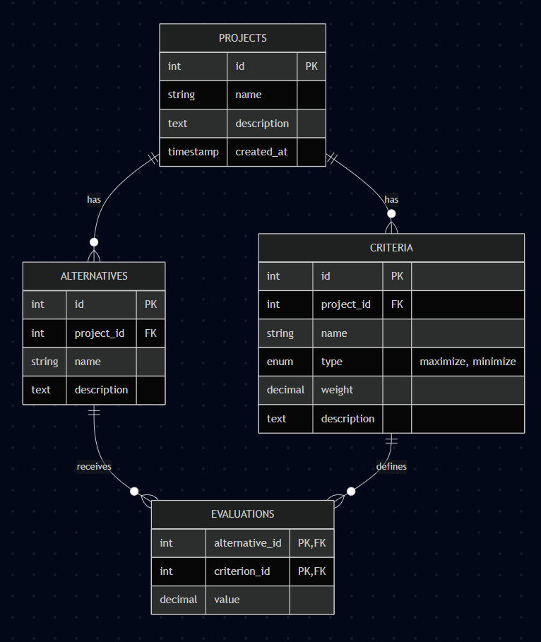
Entity Relationships:
- Projects to Alternatives/Criteria (1:N): A single project acts as an isolated workspace containing multiple alternatives and criteria. If a project is deleted, all associated entities are removed via ON DELETE CASCADE.
- Alternatives and Criteria to Evaluations (M:N): The evaluations table acts as a junction table. It features a composite primary key (alternative_id, criterion_id), ensuring that only one mathematical value exists for any specific intersection in the decision matrix.
4. The example of the filled data
